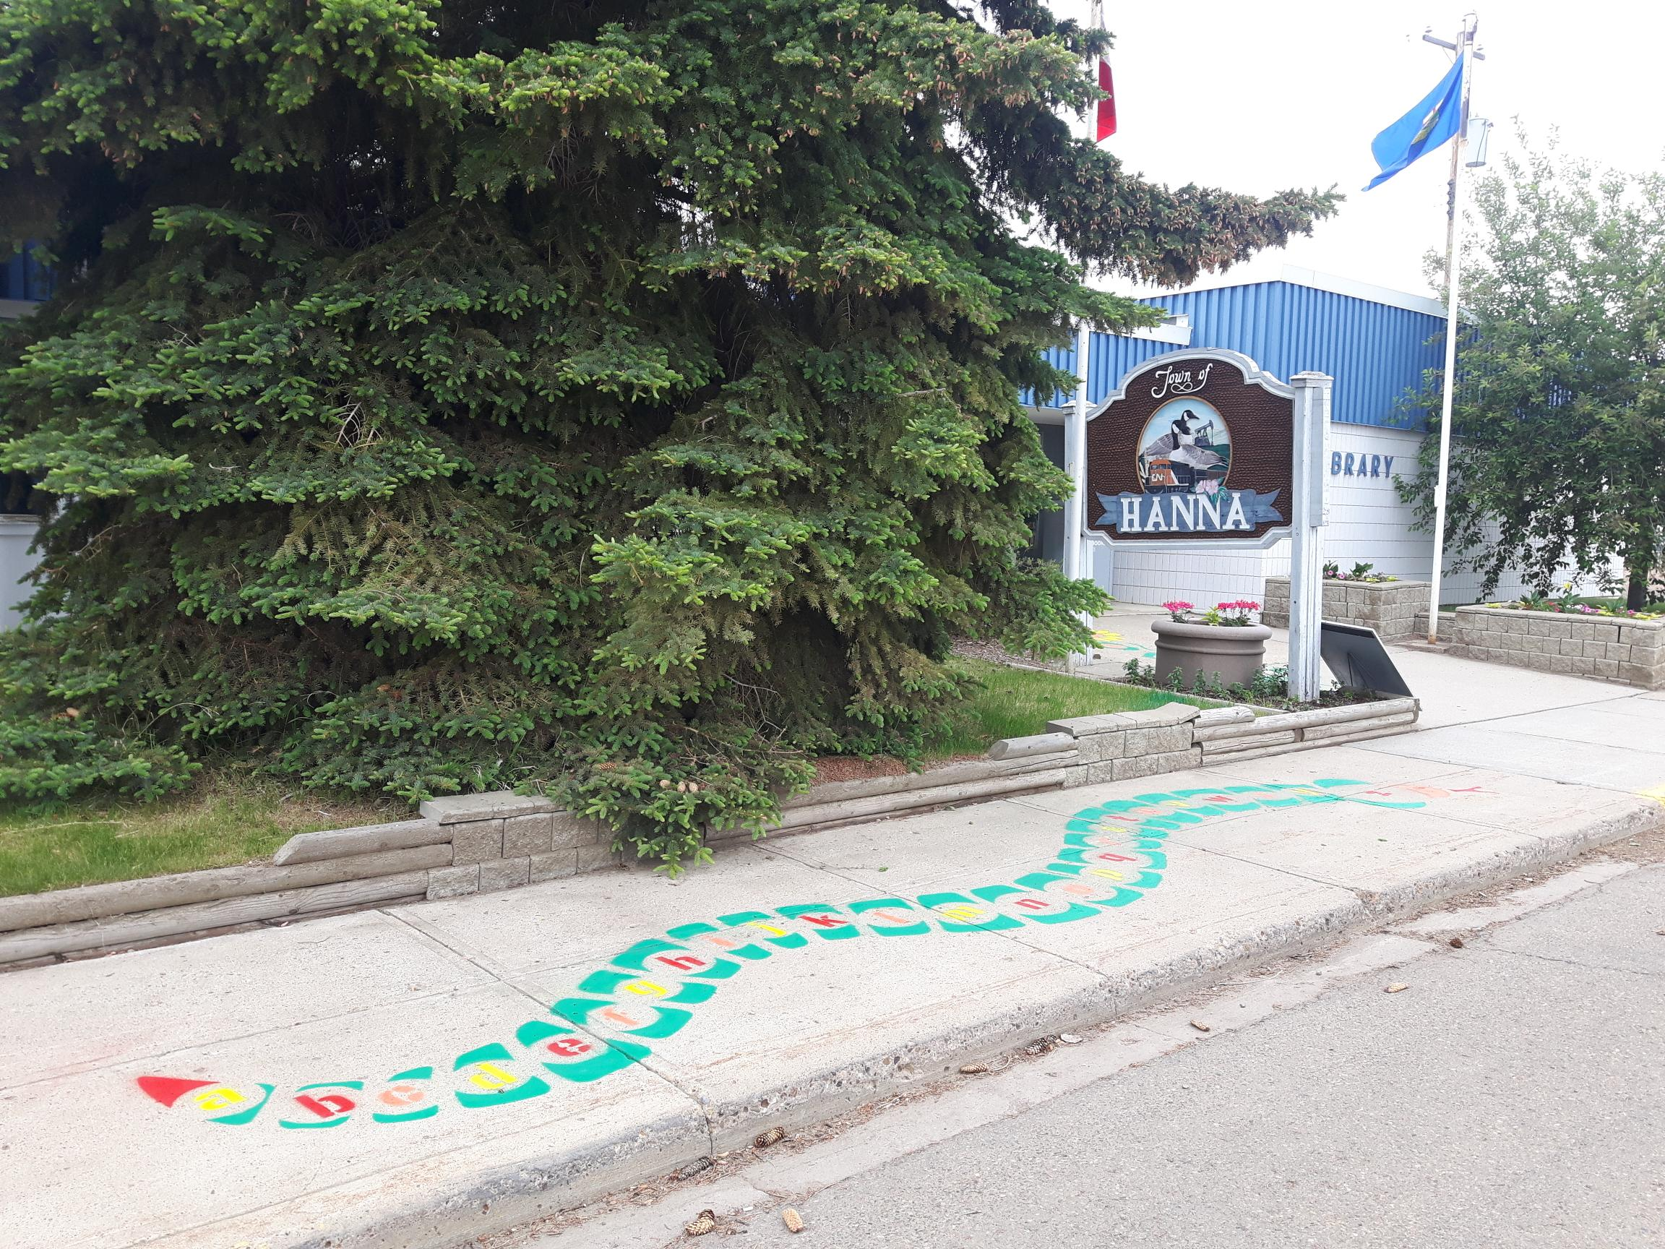

Hanna
Municipal
Library

Plan of Service 2023 - 2028

MISSION
The Hanna Municipal Library is an essential information hub that serves our community by being a safe place to connect, learn and grow.

VISION
To create a vibrant, dynamic center of learning, fostering collaborative and community valued partnerships.

PILLARS
We have identified 5 thematic pillars to organize our actions and advance our vision: Communication, Collaboration, Innovative Learning, Community and Accessibility.

Communication

2 Collaboration

We will communicate in a multifaceted way that adapts with the times and needs of our patrons.

Collaboration

We will offer a safe place encouraging community contributors to augment and diversify our programs and community presence.

Innovative Learning

We will support and expand our community of learners through a range of literacy activities and initiatives.

Community

Our community includes those within Hanna and the surrounding communities. Patrons, employees, volunteers, and donors are all valued members of our community.

Accessibility

We will be inclusive to those with all levels of skills, abilities and unique needs and endeavor to remove barriers and keep the library accessible for all.

Actions and Measures
We have identified several potential actions that could help the library achieve its mission and further its vision. For each action we have correlated the action to one or more of our Pillars, identified potential measures of success.

1.Communication Actions and Measures
Action | Pillars | Measures
Increased promotion on Social Media | 1 | Engagement metrics (likes, subscribers, reshare, etc)
Maintenance of Website | 1,5 | Website stats (visitors). Update history
Promotion of “organic” article in East Central Review through press releases. | 1,4,5 | Track the number of stories that appear
Exchange links on website with Partners | 1,2 | Increase the number of reciprocal links.
Publish a Quarterly Newsletter | 1 | Track the number of those who read online or take a printed copy. Solicit feedback.
Maintain an updated presence on Google Maps, Trip advisor and other Map based services. | 1 | Visitor and review counts. Online ratings.
Share your story – celebrate the positives. | 1,2,3 | Track programs and patron counts.

2. Feedback Actions and Measures.
Action | Pillars | Measures
Use Surveys to get feedback on programs and events. | 1,2 | Online surveys can provide statistical feeback
Monitor social media posts and pages for feedback. | 1,4,5 | Track the feedback identified and responses, if any.
Track reviews on mapping and vacation websites. | 1 | Overall scores can provide 1 metric. Anecdotes from comments can also be useful.

3.Collaboration Actions and Measures
Action | Pillars | Measures
Collaborating with business, patrons and other community groups. | 2,4,5 | Identify new engagements, and identify and track outcomes from partnerships.
Continue building the relationship with Marigold. | 2,3 | Utilized programs, training and other supports. Relationships with people at Marigold.
Support and expand the Prairieland School Division partnership. | 2,4 | Collaborative curriculum, or partnerships for SRC. Sustained tenancy.
Nurture the relationship with Brooks County Immigration Services. | 2,4,5 | Sustained tenancy, expanded partnerships.
Identify volunteers who could lead a tutorial or craft event. | 2,3,4 | New program count. Patron attendance at events.
Work with other agencies to reach those physically unable to attend our space. | 2,5 | Track new initiatives or agency/group specific patron counts.

4.Learning and Engagement Actions and Measures.
Action | Pillars | Measures
Using volunteers/business to lead programs (game nights, tutorials, creative groups) | 3,4,5 | Track new events/attendance.
Expand audio book and online opportunities | 3 | Track new events and usage (if possible)
Find free resources through Marigold or other online sources. | 3 | Expanded program offerings, new sustainable initiatives.
Promote our resources (Visual, auditory, library of things) | 3,5 | Track usage of library of things.
Identify language resources, with in-house agencies (PLSD,BCIS) | 3,4,5 | Identify new materials/needs.
Buy books to address unique needs (other languages) | 3,4 | List of new resources to address language needs.

5.Community and Accessibility Actions and Measures.
Action | Pillars | Measures
Long Term Care Outreach | 5 | New Collaborations. Patron/usage count.
Lodge Outreach | 5 | New Collaborations. Patron/usage count.
Hutterite Colonies | 5 | Patron/usage count.
Special Areas Board | 5 | Governance changes. Increased funding. Member appointment.
PLSD | 3,5 | New shared resources. Sustained partnership.
Invite local experts to lead programs. | 1,2,3,4 | New programs. More engagement.
Promote and procure materials for learning - eg. Mental Health, CNIB, Audio resources, mobility, other languages, Autism spectrum, LGBTQ, hands on learning, etc. |  | Identify new materials for accessibility.
Expand service hours as budget allows | 5 | Are hours expanded?
Encourage partnerships/sponsorships by local businesses. | 2,5 | New sponsors.
The Board of the Hanna Municipal Library would like to acknowledge and thank our focus group that came together two evenings early in our process to help us with a SWOT analysis and then to review and vision the direction for the next five years that would best serve our community. Without you this document would not be complete.

June 2023

